Course Name | ITD 2313 – Script Programming
Instructor | Prof. Greg Morris
Student Name | Dean Ramsey
Due date | 11/2/2025
Grade | Put grade earned here
Grading Comments | Put instructor comments here

Week 9 - Scripting Projects Assignment

Project #1:
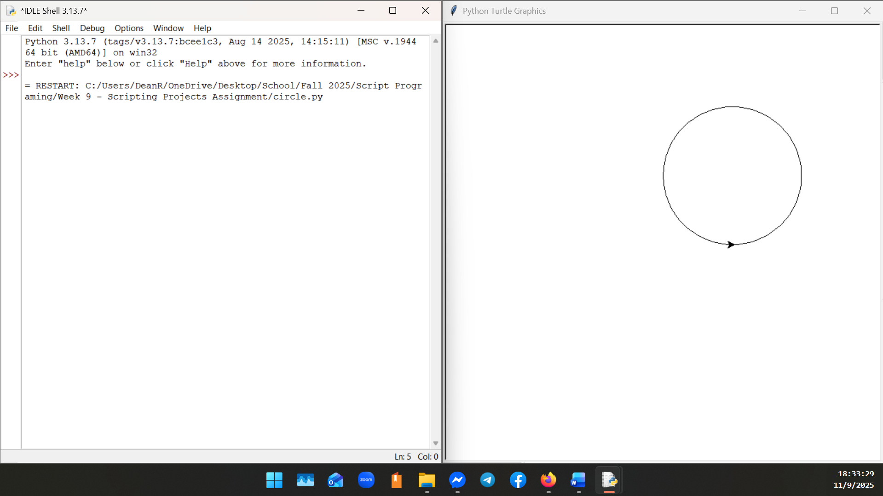

Project #3:
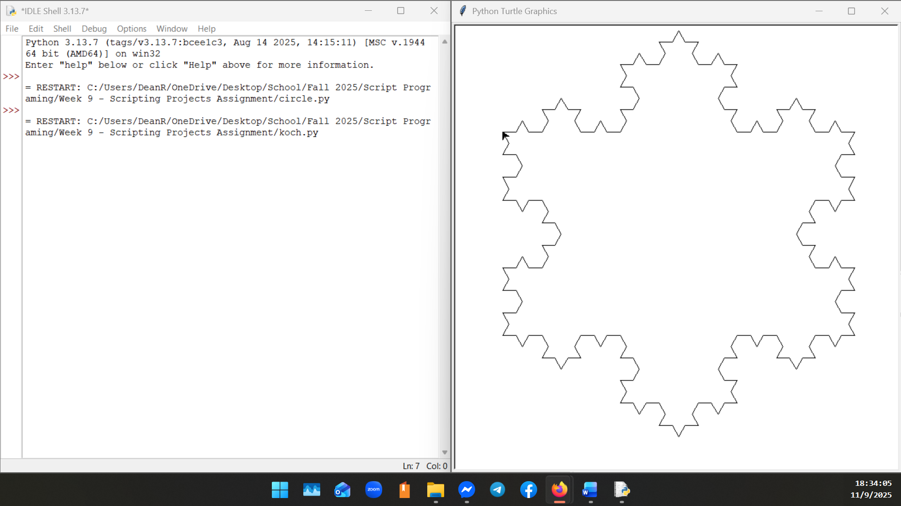
Project #8:
